How to register as a supplier on UNGM?
To create an account on UNGM, please follow these steps:
1. Go to the UNGM site. Suppliers are recommended to use Google Chrome as a web browser to navigate the UNGM site.
2. At the top right corner of the page, click on Register.
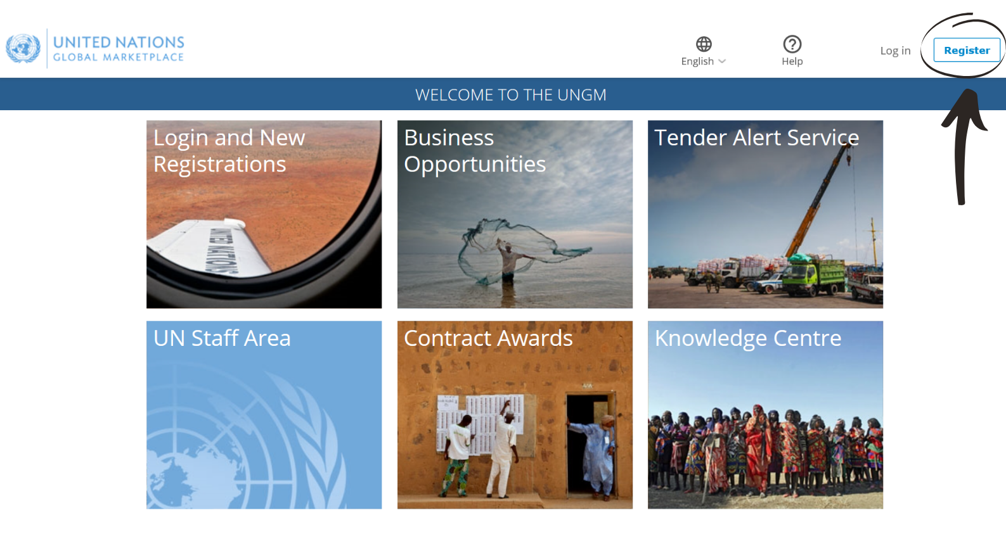
3. Click on Company (or on behalf of a company/ NGO).
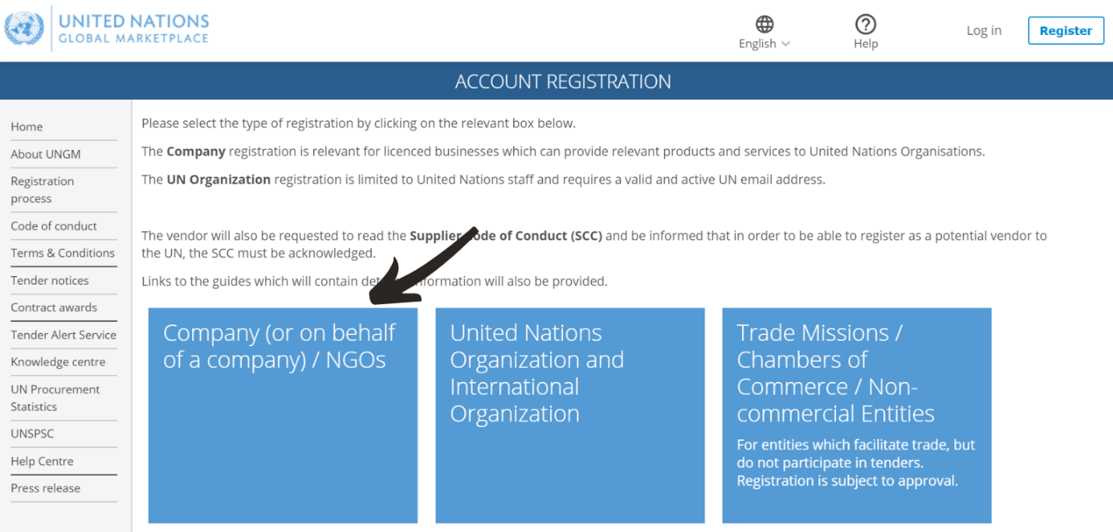

4. Download and read the UN Supplier Code of Conduct.
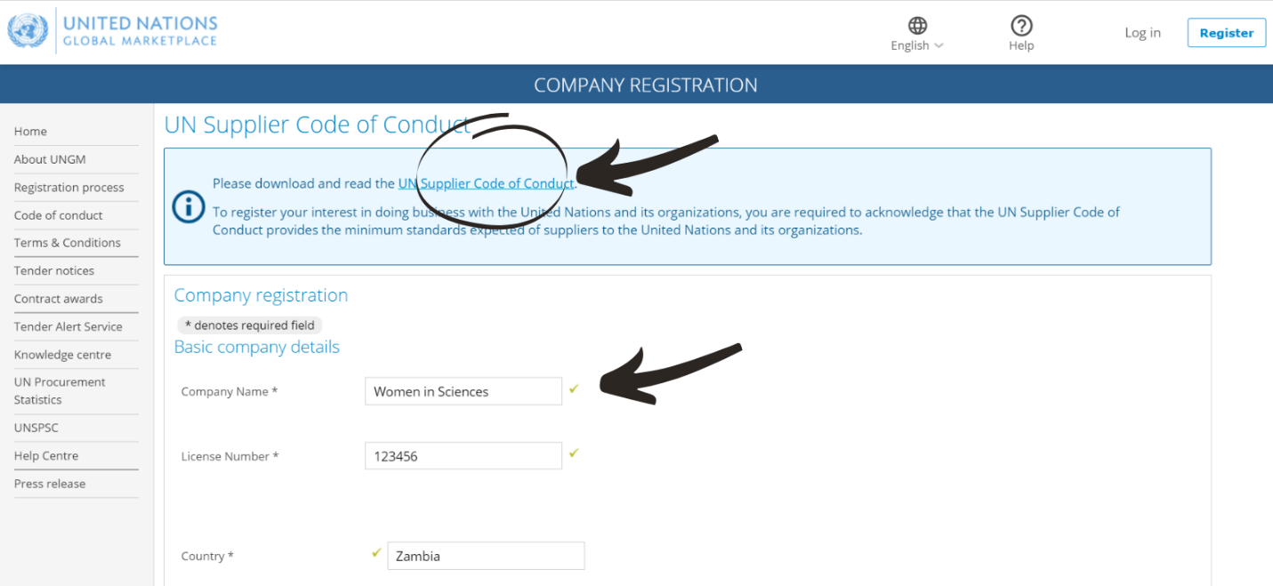

5. Complete the required information.
- The provided email address will become the account's username. It will be used for logging into the supplier's account and for authentication. It must be a valid email address.
- Provide the company’s name as it appears on the company's Certificate of Incorporation or other legal documentation.
- If a message appears that a company with a similar name already exists, suppliers are advised to contact UNGM using the contact form on the Help Center.
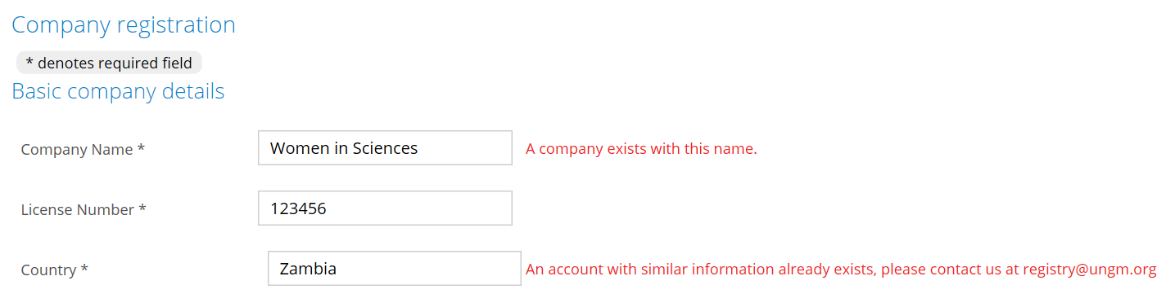

6. Confirm that you have read and acknowledge the UN Supplier Code of Conduct by ticking the checkbox and click on Send the activation link. An activation email will be sent to the email address.
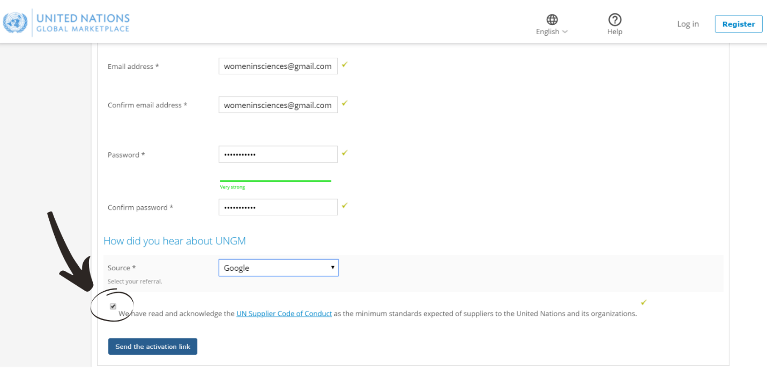
The following page will be visible in the account, requiring suppliers to activate the UNGM account.
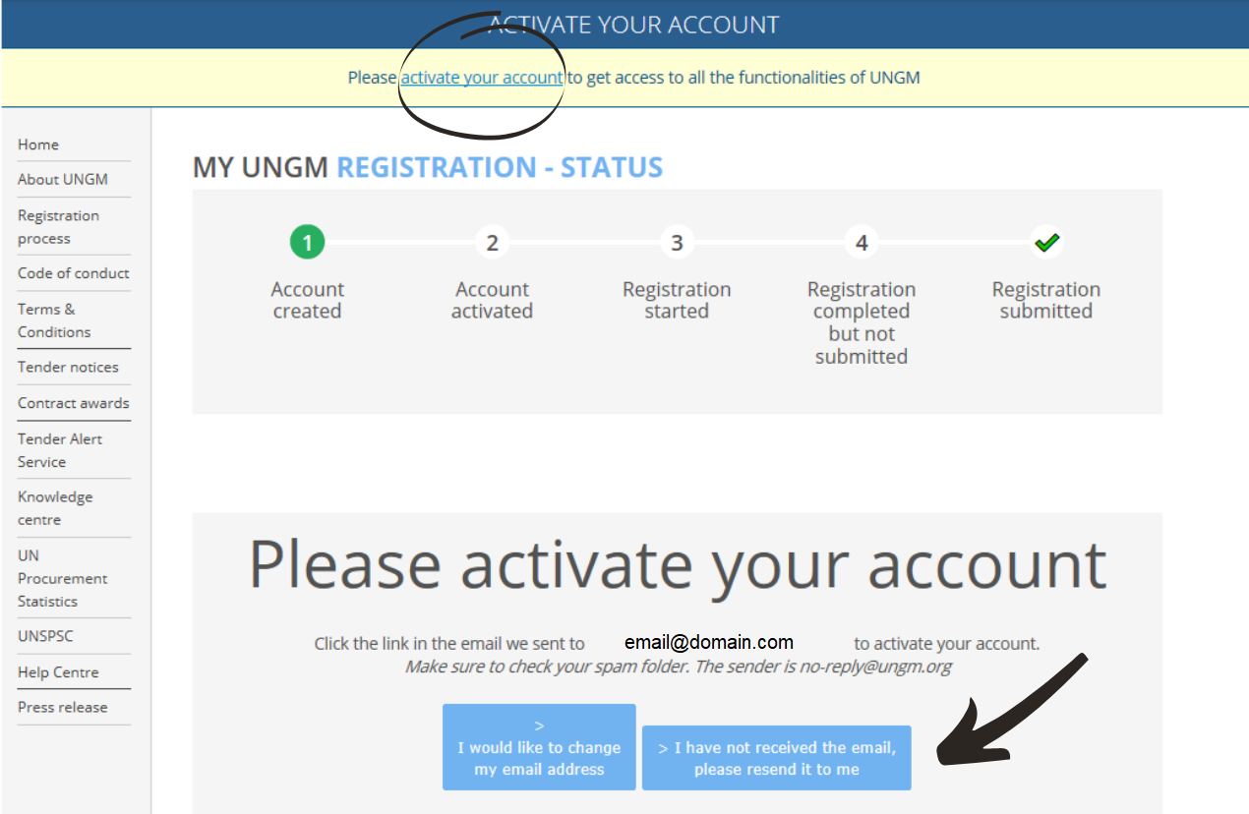

7. Access the email UNGM Account Activation - Welcome to the UNGM in your inbox and click on the Activate button. Please note, the link can only be used once.
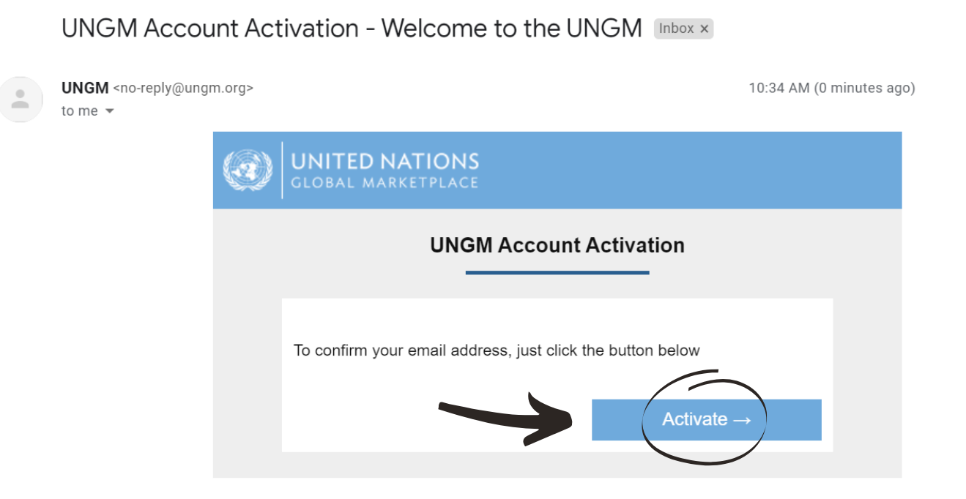
8. Once the account is activated, click on Complete the registration to proceed with the registration at the Basic level.
For more information, read the: How to complete the registration form at the Basic level? article.
